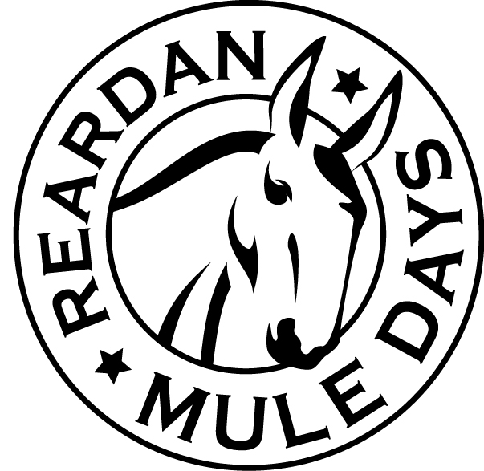**Reardan Mule Days Car Show**

PAID:  T-Shirt  Dash Plate

MAIL: T-Shirt Size ____ Dash Plate 

First Saturday in June

**One Entry per Form**

Last Name: _________________________________ First Name:______________________

Phone Number: ___________________ E-mail Address: _____________________________

Address:______________________________________________

City: ___________________ State: _______ Zip Code: _________

Make/Model: _________________________________________ Year: _________ Color: ___________

**Category Entry:** (circle one)

**A**.. Car up thru 1939 – Stock **C**.. Car 1940-1959 – Stock **E**.. Car 1960-1979 – Stock

**B**.. Car up thru 1939 – Modified **D**.. Car 1940-1959 – Modified **F**.. Car 1960-1979 – Modified

**G**.. Car 1980 & newer – Stock **J**.. Truck 1965 & older – Stock **L**.. Truck 1966 & newer – Stock

**H**.. Car 1980 & newer – Modified **K**..Truck 1965 & older – Modified **M**..Truck 1966 & newer – Modified

**N**.. Special Interest & Motorcycle

*************************************************

**REGISTRATION** must present completed entry form and fee

PRE-Registration online for an Entry Fee of $20.00 go to ReardanMuleDays.com (Deadline May 20th)

Entry fee the day of the event is $25.00 and includes a T-shirt and a Dash Plate.

**CHECK-IN** Saturday 10:00 am to 12:00 pm at the registration table in City Park on the South West Corner.

**PARADE ENTRY** Visit our Web Site to pre-register for the Annual Mule Days Parade.

**T-SHIRT** Your registration fee entitles you to receive an annual designed t-shirt and a Dash Plate. Shirts will be given at registration (sizes based on availability).

**TROPHIES / PLAQUES** Car Show awards begin at 2:30 pm. First place awards for listed categories.

**INSURANCE** Proof of insurance as required by the State of Washington is required. A copy of your insurance coverage must be in your possession during the event.

**PARKING** Spectator parking is available on the streets surrounding the park.

INDEMNITY AGREEMENT

In consideration for the acceptance of my application and their permitting me to participate in the Annual Reardan Mule Days Car Show; I, myself, my executors, my administrators and my assigns forever release all rights to ever make claims on my behalf against the Reardan Mule Days Association, its Board of Directors, Officers and/or Town of Reardan. I am aware that there is an element of risk involved with this event and I will accept responsibility for any injury or property damage for which I might incur. This is my written statement that I will assume and pay for my own property damage repairs and my own medical emergency expenses in the event of injury, accident, illness, or other incapacitation at or to and from the Car Show. I certify that I have prepared myself to be physically fit to participate in this event. I have read the above statement and understand it and my signature below confirms its acceptance.

__________________________________________________ __________________________

SIGNATURE DATE

Reardan Mule Days - PO Box 241 - Reardan, WA 99029

www.ReardanMuleDays.com