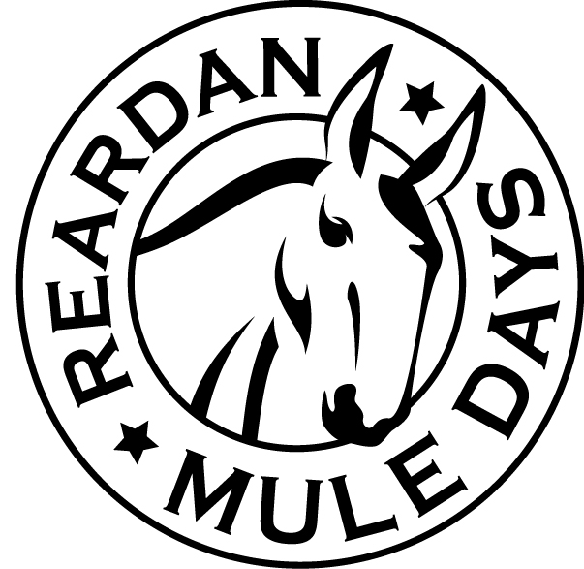
Corn Hole Tournament

First Saturday in June
Registration Form

Online registration is at www.ReardanMuleDays.com

MAIL in Registration: Complete this form and mail it with your check payable to Reardan Mule Days, c/o Corn Hole Tournament, PO Box 241, Reardan, WA 99029. Entries must be received by May 20th. Registrations that cannot be mailed to arrive on time contact the Corn Hole Chairman. One entry form must be completed for each team with all Players listed.

TEAM Entry Fee is $50.00
MAIL Entry Fee with Registration form - or - Register and Pay Entry Fee On-Line

Indemnity Agreement
I know that participating in strenuous activities such as Corn Hole is potentially hazardous. I assume all risks associated with playing in this event including but not limited to falls, contact with other participants, effects of the weather , and the condition of the playing surface; all such facts being known and appreciated by me. Knowing these facts and in consideration of your accepting my entry, I hereby for myself, my heirs, executors, administrators, or anyone else who might bring claims on my behalf, covenant not to sue, and waive release and discharge the Mule Days Corn Hole Committee, Mule Days Association, its officers, the Town of Reardan and any groups benefitting from this event, all volunteers, all sponsors, including their agents, employees, assigns or anyone acting on their behalf, from any and all claims of liability for death, personal injury, or property damage of any kind or nature whatsoever, foreseen, known or unknown. I hereby grant full permission to any and all foregoing use of photographs, video tape, motion pictures, recordings, or record of me or my likeness from this, that I am responsible for my own and my teammates conduct of play. I vow to represent myself and my team in a sportsman like manner. In the event that I fail to do so, I realize that both myself and my team may be rejected from the tournament. I agree to all the foregoing by placing my signature on this form in the appropriate space below.

Team Name: __________________________________________________________________________________
Choose Your Competition Division Level - CIRCLE ONE
Elite Division | Rec Division

The Tournament is Round Robin style that guarantees every team will play five games.
Any entry that is NOT signed will be returned – Make copies of form for each team entered
T-Shirts: Based on Availability for registrations received after May 20th

First Player
NAME: _____________________________________ ADDRESS: ___________________________________ CITY: _______________STATE: _______ ZIP: _______ PHONE: _____________________________________ E-MAIL: _____________________________________

T-SHIRT SIZE GENDER |SM |MD| LG| XL| XXL|XXXL| |MALE|FEMALE|
__________________________________ ________ PLAYER SIGNATURE DATE __________________________________ ________ PARENTS SIGNATURE (if player under 18) DATE

Second Player
NAME: _____________________________________ ADDRESS: ___________________________________ CITY: _______________STATE: _______ ZIP: _______ PHONE: _____________________________________ E-MAIL: _____________________________________

T-SHIRT SIZE GENDER |SM |MD| LG| XL| XXL|XXXL| |MALE|FEMALE|
__________________________________ ________ PLAYER SIGNATURE DATE __________________________________ ________ PARENTS SIGNATURE (if player under 18) DATE

Tournament Information

First Saturday in June Bags Fly at: 1 pm
Rules / Scoring meeting at: 12:30 pm

Tournament Location: Reardan WA
Spokane Ave between Lake Street and Laurel Street
(Fire Station if rain).

Prizes posted on our Web Site
Airmail Competition - $5 for four throws
Anyone can complete. You get four throws to get your bag into the hole via airmail (the bag cannot touch anything) your name will be added to a jar, the winner will be pulled.

Print Complete Guidelines and Event Details
www.ReardanMuleDays.com
E-mail Questions to: cornholemuledays@gmail.com

