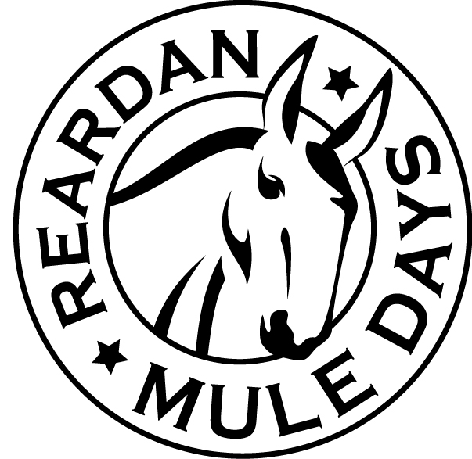
POKER RIDE – Registration Form

First Saturday in June
Starting at 2:00 ride ends at 4:30

REGISTRATION: MAIL Entry Fee with Entry form -Or- Enter & Pay Fee On-Line -or- Enter and Pay Day of Ride
Register the day of the ride: Complete this form and pay entry fee at the Starting site of the ride.
PRE-Register by mail: Mail your entry fee to Reardan Mule Days, PO Box 241, Reardan, WA 99029. (Deadline May 20th)
On-Line Registration: Online registration is at www.ReardanMuleDays.com (Deadline May 20th)

T-Shirts: Guaranteed for Pre-Registration and On-Line Registration. Day of the event T-shirts based on Availability.

ENTRY FEE: 18 and older Poker Ride - $30.00 E-Mail Questions:
Under 18 Crazy 8 Ride - $10.00 Ryanrett@yahoo.com .. or .. Tdm6333@gmail.com

Indemnity Agreement
I know that participating in strenuous activities such as Poker Ride is potentially hazardous. I assume all risks associated with playing in this event including but not limited to falls, contact with other participants, effects of the weather , and the condition of the riding surface; all such facts being known and appreciated by me. Knowing these facts and in consideration of your accepting my entry, I hereby for myself, my heirs, executors, administrators, or anyone else who might bring claims on my behalf, covenant not to sue, and waive release and discharge the Mule Days Corn Hole Poker Ride Committee, Mule Days Association, its officers, the Town of Reardan and any groups benefitting from this event, all volunteers, all sponsors, including their agents, employees, assigns or anyone acting on their behalf, from any and all claims of liability for death, personal injury, or property damage of any kind or nature whatsoever, foreseen, known or unknown. I hereby grant full permission to any and all foregoing use of photographs, video tape, motion pictures, recordings, or record of me or my likeness from this, that I am responsible for my own and my teammates conduct of play. I vow to represent myself in a sportsman like manner. In the event that I fail to do so, I realize that I may be rejected from the ride. I agree to all the foregoing by placing my signature on this form in the appropriate space below.

Signature: _________________________________________________ Date: ___________________
(parent sign if rider is under 18)

Rider Information

NAME : _____________________________________ ADDRESS: ___________________________________
CITY: _______________STATE: _______ ZIP: _______ PHONE: _____________________________________
E-MAIL: _____________________________________
Amount to Pay
Rider Entry Fee: 18 and older Poker Ride $30.00 $______________
Under 18 Crazy 8 Ride $10.00 $______________
T-Shirt Order Fee: Adult Size (check below) $18.00 $______________
Youth Size (check below) $16.00 $______________
TOTAL Amount to pay $______________
Youth Size $16 ___ Youth Small ___ Youth Medium ___ Youth Large ___ Youth XL
Adult Size $18 ___ Small ___ Medium ___ Large ___ X-Large ___XX- Large ___XXX-Large

Ride Information

Date: First Saturday in June
Registration Starts: 1:30
Ride Starting at: 2:00 pm
Ending at: 4:30 pm Prizes at 4:45 pm
Dinner Following Prizes

Ride Location: Reardan WA
Starting and Finishing at the Reardan Baseball Fields

RULES:
Each Rider is given a Game Sheet which will be filled in as they progress along the route. At each designated stop, the Rider draws a card at random. The card drawn is recorded by the Dealer on each Rider's Game Sheet, and the winner of the Ride is the Rider who makes the best Game Sheet Hand at the end of the event.

Print Complete Guidelines and Event Details
www.ReardanMuleDays.com

