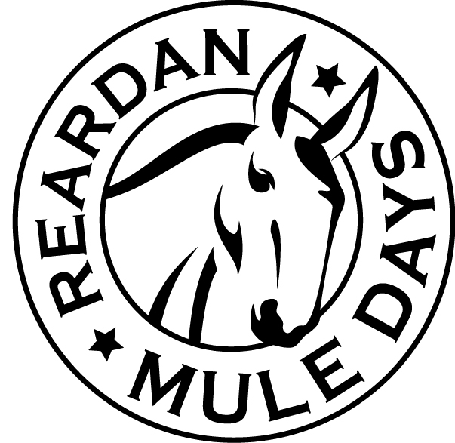
Reardan Mule Days
First Saturday in June
Food Truck RoundUp - Registration Form

We invite you to participate in the Annual Mule Days celebration on the first Saturday in June. The Food Truck Roudup takes place on the street of Reardan with plenty of space for those attending. We do everything possible to make your visit a pleasurable and profitable experience. Many spectators, event participants and visitors look forward to this special event and will want to know about your products.

You Must Call to Pre-Register – 316-259-5481

Register and Pay On-Line At: www.ReardanMuleDays.com click on “Food Truck Roundup”
Mail Registration & Payment Payable to: Reardan Mule Days Association, PO Box 241, Reardan, WA 99029

Owner Name: ______________________________ Business Name: _____________________________
Phone Number: ______________________ E-mail: _________________________________________
Address: _____________________________ City: _________________ State:________ Zip: _________
Representative: ________________________________ Tax #: _______________________ (Individual Responsible & Manning Truck/Tent)

Type of Truck/Tent and Fees: Size of truck/tent Cost TOTAL FEE

Food Truck ____________ $75.00 $__________
Food Tent ____________ $75.00 $__________

Other ______________ ____________ $75.00 $__________

TOTAL DUE $__________

Power is not included in your fee – You must provide your own power source
YOU MUST CALL AND CONFIRM PRIOR TO REGISTRATION

Recommended All Tents have weights --- no In-ground stakes allowed

Menu Items to be Served: _____________________________________________________
___________________________________________________________________________
___________________________________________________________________________
___________________________________________________________________________
___________________________________________________________________________

INDEMNITY AGREEMENT

In consideration for the acceptance of my application and their permitting me to participate in the Reardan Mule Days celebration as a Food Truck/Tent or other Food Exhibitor. I, myself, my executors, my administrators and my assigns forever release all rights to ever make claims on my behalf against the Reardan Mule Days Association, its Board of Directors, Officers and/or Town of Reardan. I am aware that there is an element of risk involved with this event and I will accept responsibility for any injury or property damages for which I might incur. This is my written statement that I will assume and pay for my own property damage repairs and my own medical emergency expenses in the event of injury, accident, illness, or loss of property while traveling to or from or while participating in said Reardan Mule Days. I have read the above statement and understand it and my signature below confirms it’s acceptance.

__________________________________________________ __________________________
SIGNATURE DATE
All contracts must be signed by the person responsible for your Truck/Tent and returned with required fees
You are responsible for the Security of your Truck/Tent & Product. Mules Days takes no responsibility for lost or stolen items.

