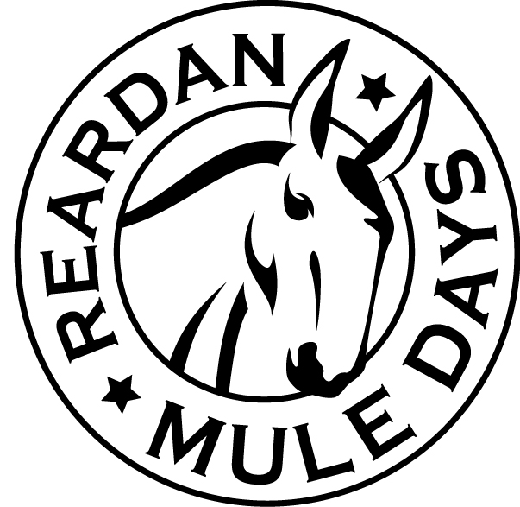
Reardan Mule Days Vendor
First Saturday in June
Vendor Registration Form

We invite you to participate in the Annual Mule Days celebration on the first Saturday in June. The craft fair takes place in the Reardan City Park to give plenty of room for booths and more aisle space for those attending. We do everything possible to make your visit a pleasurable and profitable experience. Thousands of spectators, event participants and visitors look forward to this special event and will want to know about your products.

Register and Pay On-Line At: www.ReardanMuleDays.com
Mail Registration and Payment to: Reardan Mule Days Association, PO Box 241, Reardan, WA 99029
MAKE CHECKS PAYABLE TO: Reardan Mule Days Association

Owner Name: ______________________________ Business Name: _____________________________
Phone Number: ______________________ E-mail: _________________________________________
Address: _____________________________ City: _________________ State:________ Zip: _________
Representative: ________________________________ Tax #: _______________________ (Individual Responsible & Manning Booth)

Type of Booth and Fees: Booth Size is 10’x10’ Extra Booth TOTAL FEE

Craft Vendor $45.00 $40.00 $__________
Other (non-profit or Misc) $45.00 $40.00 $__________

Commercial Vendor $75.00 $40.00 $__________

TOTAL DUE $__________

Power is not included in your booth fee – You must provide your own power source

** Food Service Vendors must register separately see “Food Truck Roundup Form” on Web Site **

Recommended All Tents have weights --- no In-ground stakes allowed

List Items to be Displayed: _____________________________________________________
___________________________________________________________________________
___________________________________________________________________________
___________________________________________________________________________
___________________________________________________________________________

INDEMNITY AGREEMENT

In consideration for the acceptance of my application and their permitting me to participate in the Reardan Mule Days celebration as a Commercial or Non-Profit Exhibitor. I, myself, my executors, my administrators and my assigns forever release all rights to ever make claims on my behalf against the Reardan Mule Days Association, its Board of Directors, Officers and/or Town of Reardan. I am aware that there is an element of risk involved with this event and I will accept responsibility for any injury or property damage for which I might incur. This is my written statement that I will assume and pay for my own property damage repairs and my own medical emergency expenses in the event of injury, accident, illness, or loss of property while traveling to or from or while participating in said Reardan Mule Days. I have read the above statement and understand it and my signature below confirms it’s acceptance.

__________________________________________________ __________________________
SIGNATURE DATE
All booth contracts must be signed by the person responsible for your booth(s) and returned with required fees
You are responsible for the Security of your Booth and Product. Mules Days takes no responsibility for lost or stolen items.

