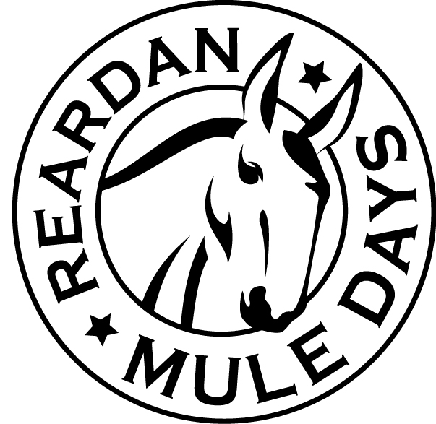

**Reardan Mule Days Parade**

**First Saturday in June**

**Entry Form**

INSTRUCTIONS: Participate in the Reardan Mule Days Parade – it’s never too late to register. Please DO NOT throw candy or other items from your float. Provide two signs for your car. Community floats will be judged at 8:30 am in the unloading area. Judging for equestrian, community fairs, rodeo royalty, drill teams, marching groups and commercial floats will be done during the parade. Proof of insurance for moving vehicles is required. To guarantee we announce you, entries must be received two weeks prior to the parade. If you have any questions, contact the parade Chairman.

|  |  |  |  |
| --- | --- | --- | --- |
| **Contact Information** | | | |
| Name | | E-mail Address | |
| Address | | Phone Number | |
| City | State | | Zip Code |
| **Entry Information** | | | |
| Unit Name (i.e. Shriners, marching /drill team, political organization) | | | |

|  |  |  |  |  |  |  |  |  |
| --- | --- | --- | --- | --- | --- | --- | --- | --- |
| **Choose From One Category** | | | | | | | | |
| Floats | | Equestrian | | | | Motor | | |
| * Community * Organizations * Novelty * Chamber * School * Other | | * Rodeo / Royalty * Individual * Team * Fair * Group * 4H / FFA | | | | * Street Rod * Antique * Muscle * Classic * Motorcycle * Farm Equipment | | |
| * I am entering a motor vehicle (proof of insurance is required to participate in parade). | | | | | | | | |
| Please describe your entry: | | | | | | | | |
| Please tell us in 75 words or less how you would like your entry announced: | | | | | | | | |
| Is your entry loud? (if yes, you will not be placed behind animals)   * YES * NO | | | | CLASS REUNION:  RSVP for BBQ Luncheon ___________________  Contact the BBQ Luncheon Chairman for any questions | | | | |
| **Royalty Information**  RSVP for Luncheon: Royalty _______ Chaperone ______ (limit 2) | | | | | | | | |
| Princess 1 Name | Address | | City | | State / Zip | | Phone | Email |
| Princess 2 Name | Address | | City | | State / Zip | | Phone | Email |
| Princess 3 Name | Address | | City | | State / Zip | | Phone | Email |
| Princess 4 Name | Address | | City | | State / Zip | | Phone | Email |

Reardan Mule Days - PO Box 241 - Reardan, WA 99029

www.ReardanMuleDays.com